OSCN LAB-08
PROGRAM 8
Lab Task: Round Robin CPU Scheduling (Time Quantum = 3 ms)
A system receives the following processes NOT in arrival order:
Process | Arrival Time (AT) | Burst Time (BT)
P1 | 4 | 7
P2 | 0 | 5
P3 | 6 | 3
P4 | 2 | 9
P5 | 1 | 4
Student Tasks
- Do NOT reorder by arrival time.
Simulate exactly as given.
- Apply Round Robin Scheduling with Time Quantum = 3 ms.
- Draw the complete Gantt Chart.
- Compute for each process:
  - Completion Time (CT)
  - Turnaround Time (TAT = CT − AT)
  - Waiting Time (WT = TAT − BT)
- Compute:
  - Average TAT
  - Average WT
- Write a C program that performs RR scheduling.
- Compare your manual result with the program output.
CODE:
#include <stdio.h>
int main() {
int n = 5, tq = 3;
int AT[] = {4, 0, 6, 2, 1};
int BT[] = {7, 5, 3, 9, 4};
int remBT[5], CT[5], TAT[5], WT[5];
for (int i = 0; i < n; i++)
remBT[i] = BT[i];
int time = 0, completed = 0;
while (completed < n) {
int idle = 1;
for (int i = 0; i < n; i++) {
if (AT[i] <= time && remBT[i] > 0) {
idle = 0;
if (remBT[i] > tq) {
time += tq;
remBT[i] -= tq;
} else {
time += remBT[i];
remBT[i] = 0;
CT[i] = time;
completed++;
}
}
}
if (idle)
time++;
}
printf("\nProcess\tAT\tBT\tCT\tTAT\tWT\n");
for (int i = 0; i < n; i++) {
TAT[i] = CT[i] - AT[i];
WT[i] = TAT[i] - BT[i];
printf("P%d\t%d\t%d\t%d\t%d\t%d\n",
i+1, AT[i], BT[i], CT[i], TAT[i], WT[i]);
}
return 0;
}
MANUAL OUTPUT:
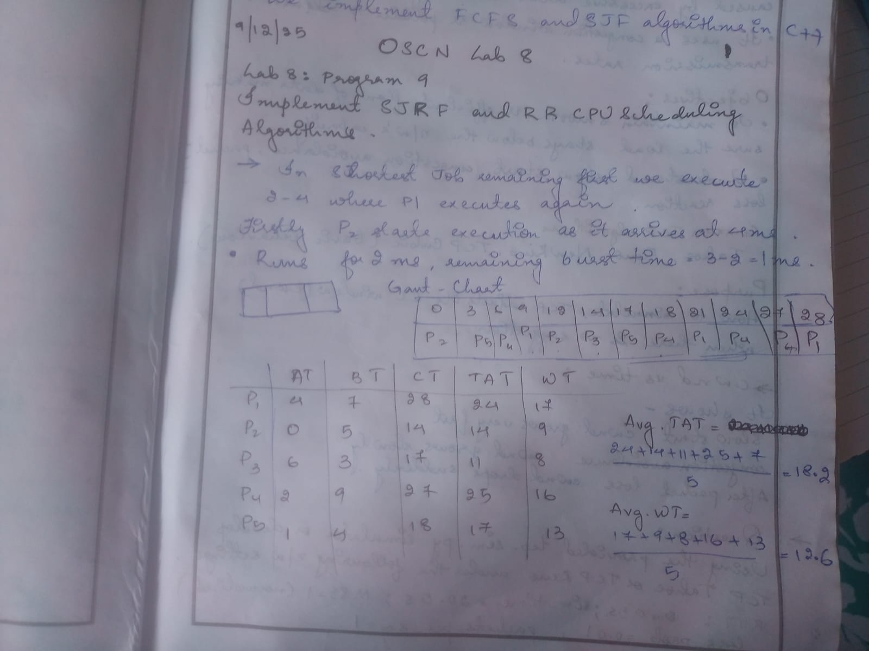

OUTPUT:
